Ball and Beam Experiment

**2017**

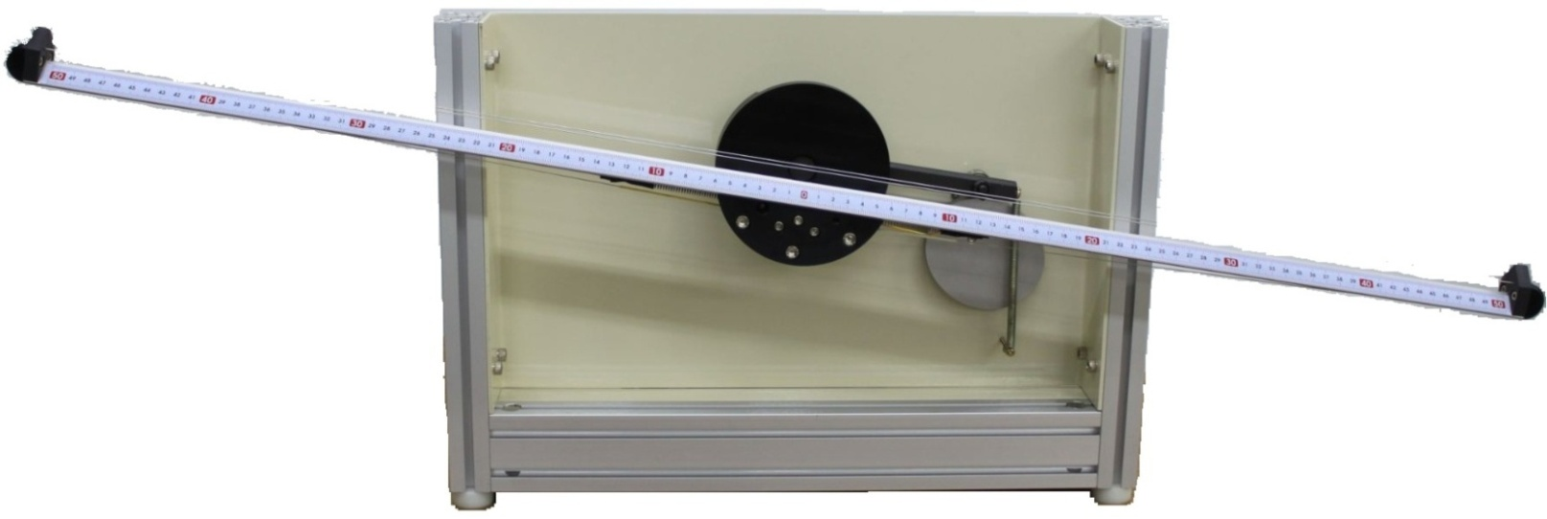

**\*MyRIO version**

## Section 1. Introduction

**1.1 General**

The Ball and Beam is one of a unique range of products designed specifically for the theoretical study and principles. This includes the analysis of static and dynamic systems using analogue and digital techniques.

A simple aerospace example of an unstable system is a rocket at take-off, when it must be balanced by thrust motors so as to follow its required trajectory. Without active control of the thrust motors the rocket will tilt and crash. A further aerospace example is the modern control-configured fighter aircraft. In order to achieve faster maneuver rates, these aircraft are designed to be aerodynamically unstable. Without stabilizing flight control system the aircraft would crash.

The Ball and Beam relates specifically to problems of control of unstable systems as they would typically occur in aerospace and associated control industries. It may also, however, be used as a practical introduction to the design, operation and application of control systems in general.

In particular with the Ball and Beam, we are able to examine the control of the position of a ball as it rolls on top of a pivoted beam. If left free the ball will roll away from an initial position to one end of the beam. In this sense the control of ball position is said to be unstable. The stabilization of the ball at required position is an illuminating control study which has parallels in the control of rockets at launch and the balancing of bipedal robots amongst other applications.

The experimental topics which may be investigated include:

1. The behavior of unstable systems.
2. Measurement of system characteristics.
3. Stabilization of an unstable system by phase lead controllers.
4. Stabilization of an unstable system using Proportional + Derivative (PD) control action.
5. The use of cascade control.

**1.2 Ball and Beam Apparatus**

The Ball and Beam apparatus is shown in Figure 1. It consists of a beam which is normally horizontal, but which can be rotated through an angle of ±10**°** by an electrical motor attached to the beam via a profiled cam. The beam angle is sensed by a servo potentiometer mounted at the rear of the beam shaft.

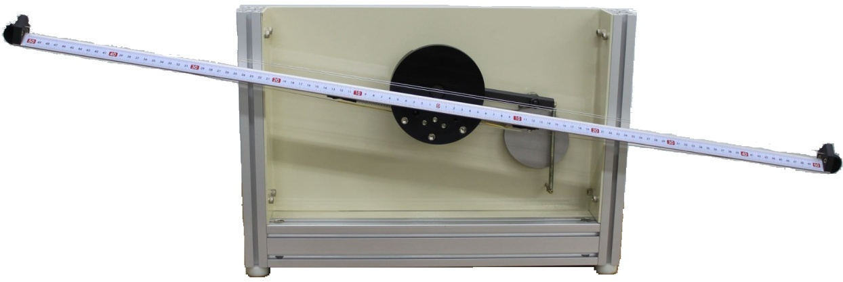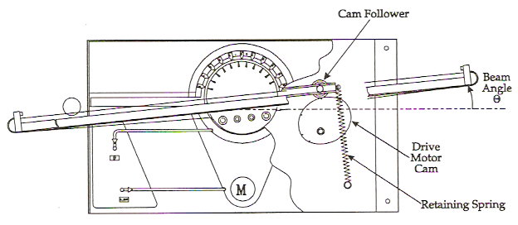

Figure 1

A voltage signal in the range -10v to +10v applied to the motor drive varies the speed of the motor. A profiled cam attached to the motor shaft links the main beam via a secondary beam.

Two parallel wires are stretched along the top of the beam such that a steal ball may roll the length of the beam, supported by the wires. One of the wires is connected to a voltage source. When the ball rests between the wires it allows a fraction of the source voltage to be measured at the other wire using potentiometer techniques. The voltage fraction provides a voltage which is proportional to the balls position along the length of the wires. By suitable conditioning circuits of the voltage, an output signal is obtained which is proportional to the ball position on the beam.

The main beam on which the ball rests is attached to a smaller secondary beam, located directly behind it. The beam is tilted by the action of a profiled cam connected to a drive motor shaft, acting upon a cam follower on the secondary shaft. The cam profile gives a linear relationship between the motor/cam shaft angle and the beam angle over a beam angle range of ±10**°**. A retaining spring ensures the cam follower remains in contact with the cam even during rapid beam angle changes. Figure 2 illustrates the cam/beam assembly.

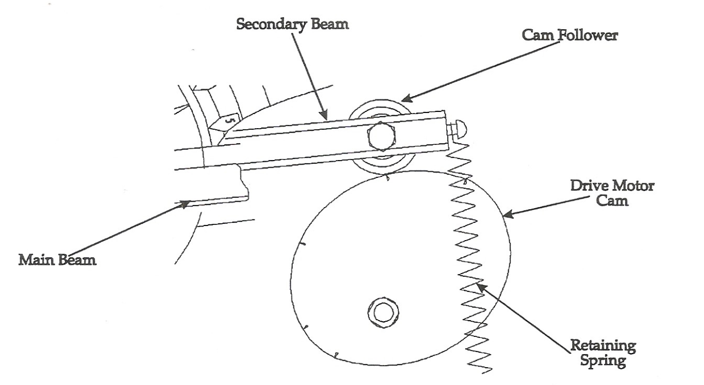

Figure 2

Connection between external power supplies for potentiometers. Fig.3 illustrates the signal wires assembly.

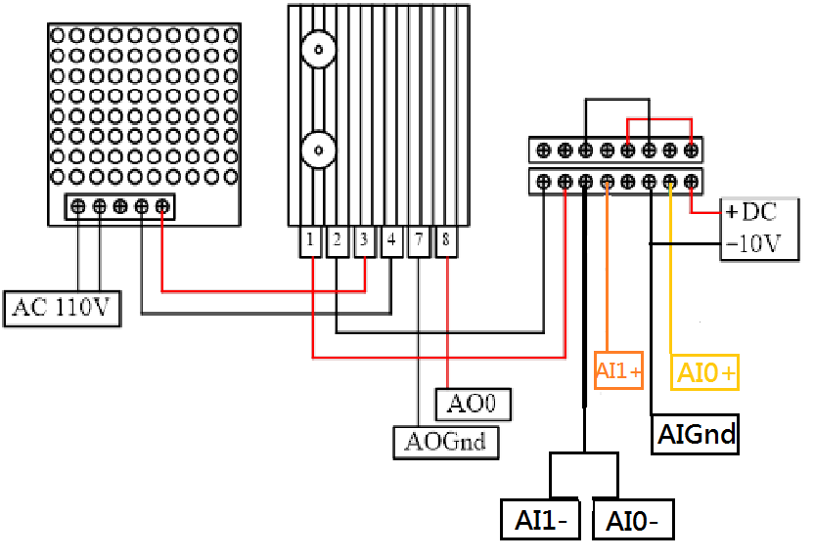

Figure 3

**Section 2. Control Theory**

**2.1 Fundamentals of Control Theory**

**2.1.1 Introduction**

## This section provides an introduction to control engineering principles by firstly considering the operating characteristics of the individual elements used in typical control engineering systems. It then further considers the performance of these elements when combined to form a complete control engineering system.

The text includes the development of control theory relating to unstable systems like the Ball and Beam. This is consider essential in ensuring that the student both understands and is able to explain the results from the practical investigations contained in experiments.

The following theory and examples are based upon the need to maintain a ball and beam at selected positions under varying operating conditions.

**2.1.2 Control Principles**

Consider a simple system where a beam is tilted back and forth to control the position of a ball at a desired position, as shown in Figure 4.



Figure 4

For fixed beam angle, the ball will accelerate along the beam at a rate which is proportional to the beam angle. Under these conditions.

**Ball acceleration = *k*  Beam Angle**

This is said to be an unstable system because for a constant input (beam angle) the ball does not stabilize at a steady position, but moves at a constant acceleration until the ball reaches the end of the beam.

When operated in this way the system is an example of a Open-Loop Unstable system because no information concerning the ball position is fed back to the motor to compensate for the unstable ball behavior.

The same configuration as described above exists in many industrial situations where the output increases without limit or oscillates in an unstable manner unless stabilizing compensation is provided. In practice, the instability may be part of a much larger and sophisticated system.

As such, even if the beam were positioned to be perfectly horizontal and the ball stationary, then external effects and considerations which are not directly part of the ball and beam system may destabilize the ball. For example, suppose the ball and beam was inside a vehicle. It is easy to see that the position of the vehicle would cause the ball to move on the beam. In such a situation we may suppose that an operator is tasked to observe changes in the ball position and make manual adjustments to the beam position when the ball moves. In this example the operator provides;

1. The measurement of position by observing the ball position against a calibrated scale.
2. The computation of what remedial action is required by using their knowledge and experience to increase or decrease the beam angle a certain amount.
3. The manual effort to accomplish the beam adjustment, required to achieve the desired changes in the system performance, or by adjusting the supply to the motor.

Again, reliance is made on their experience and concentration to achieve the necessary adjustment with minimum delay and disturbance to the system.

A modern system is to use a transducer to produce an electrical signal which is proportional to the ball position. Electronic circuits would then generate an Error Signal which is equal to the difference between the measured signal and the Reference Signal. The Reference signal is chosen to achieve the ball position required. It is also termed the Set Point (or Set Position in the case of a position control system).

The Error Signal is then used, with suitable stabilizing feedback controller and power amplification, to drive the beam motor and so automatically adjust the actual performance of the system. The use of a signal measured at the output of a system to control the input condition is termed Feedback.

In this way the information contained in the electrical signal concerning the ball position, whether it be constant or varying, is used to control the beam angle to maintain the ball position as constant as possible under external conditions. This is then termed a Closed-Loop Control System because the output state is used to control the input condition.

Figure 5 shows a typical arrangement for a closed-loop control system for the ball and beam which included a feedback loop.

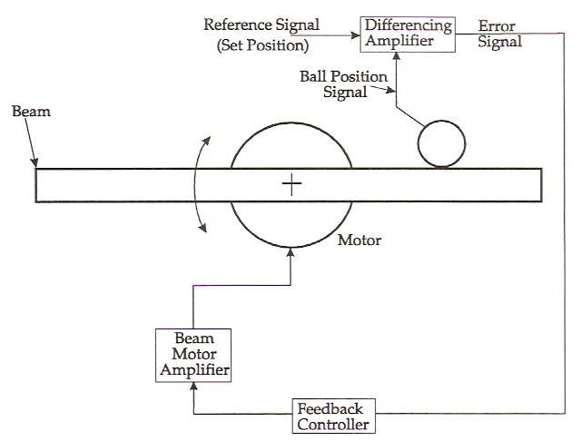

Figure 5

The schematic diagram shown in Figure 6 represents the closed-loop control system described previously.

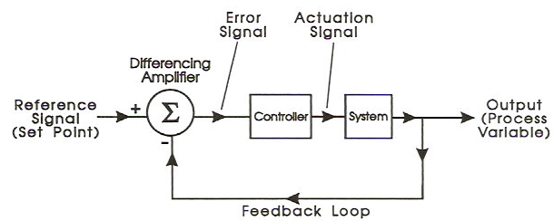

Figure 6

Consider the situation when the system is initially in equilibrium with the beam horizontal and then the ball is caused to move by an external disturbance. With no immediate change in the beam angle, the ball will roll and the error signal increase. This will in turn increase the supply to the beam motor and the beam will tilt automatically to oppose the ball movement and return it to its original position.

As the ball is being returned to the original set position value, the error signal reduces causing the energy supplied to the beam motor to also reduce. Eventually the supply to the motor reduces to zero when a new equilibrium position was produced where the ball was restored to its reference position and the Error achieves a new constant value. The difference between the actual position and the set position is termed the Steady State Error of the system.

If the Gain of the amplifier was increased, the steady state error would be reduced but not totally removed, for exactly the same reasons as given previously. If the gain were to be increased too much the possibility of instability may be introduced. This is a particular feature of the ball and beam where the controller type and gain must be especially chosen so as to stabilize the ball position.

The system described above is said to have Proportional Feedback since the gain of the amplifier is constant. This means that ratio of the output to the input is constant once selected.

In order to maintain the ball at a stable position, or return it when moved, there must be a predictive element in the controller which a proportional control amplifier does not have. That is, the beam needs to tilt before the ball reached the set position and then levels to hold it in that position.

Hence, on its own proportional control cannot maintain the ball position on the beam at the desired position, other than by manual adjustment of the reference. Moreover, proportional gain alone would not be able to compensate fully for any changes made to the operating conditions.

Stable operation with zero error may, however, be achieved by using a controller which is capable of Proportional and Derivative Control (PD).

Figure 7 shows a typical schematic diagram of a PD controller.

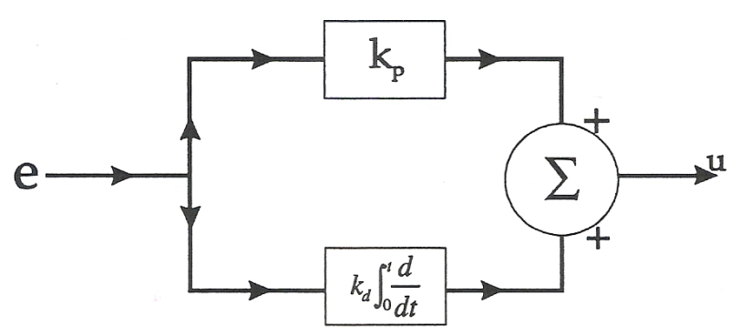

Figure 7

A Differentiating Amplifier is designed such that its output is proportional to the derivative of the input. The use of differential action in an unstable control situation is that is provides a predictive capability such that the controller can anticipate the behavior of the output variable and introduce a compensatory action before the instability can develop.

In terms of the ball and beam if it stars to roll, the differential amplifier produces a signal proportional to the ball and velocity. Then even if actual error is small and the proportional control action is correspondingly small, the differential amplifier output will introduce a larger compensating control action proportional to the ball velocity.

In practice, a differentiate would be used with proportional amplification to give an overall system response of a desired characteristic. Used alone a derivative controller gives a very rapid step response which can also amplify noise. Combined with proportional action is a PD controller the response rate can be made gentler and yet retain the stabilizing influence of the derivative action.

In practice a pure differentiator is limited in the rates of change which it can follow, and to avoid excessive high frequency noise amplification it is customary to place a high frequency filter in the differential amplifier.

The PD controller can be used to stabilize the ball and beam system. More generally the closely related phase lead form of controller will be used.

**2.2 Advanced Principles of Control**

**2.2.1 Introduction**

In this section we build on the introductory material of Section 2.1 and describe more advanced methods for the analysis and control of the Ball and Beam system.

The ability to analyze a system, real or otherwise, is especially important in establishing the relevant design parameters for new plant or in predicting the performance of existing equipment which is to operate under new conditions. Being able to predict the performance of any complex engineering system in advance of its construction and operation will both reduce costs and also minimize project development time.

**2.2.2 Control Strategy : Cascade Control**

Before discussing the modeling and controller design techniques to be employed with the ball and beam it will be useful to present an overview of the control strategy to be used.

The ball and beam system consists, as outlined previously, of a motor driven beam with a ball free to roll on the beam. The ball position is controlled by manipulating the beam angle. The system can be represented schematically as shown in Figure 8.

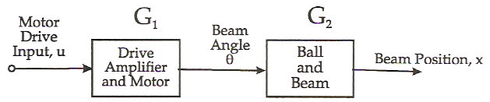

Figure 8

Because the beam angle is measured using potentiometric techniques and the motor drive input controls the rate of change of beam angle, it is sensible to place the beam angle position control loop around the motor and drive amplifier as shown in Figure 9.

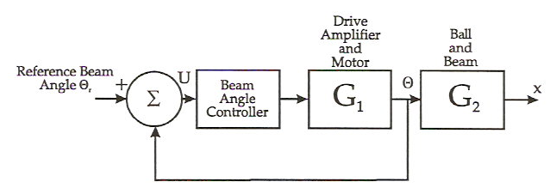

Figure 9

If the beam angle control loop is designed to respond rapidly and accurately to the reference beam angle , then the control loop of the ball position, *x*, can be designed by considering  to be the control input. The ball position controller then forms an outer loop as shown in Figure 10.

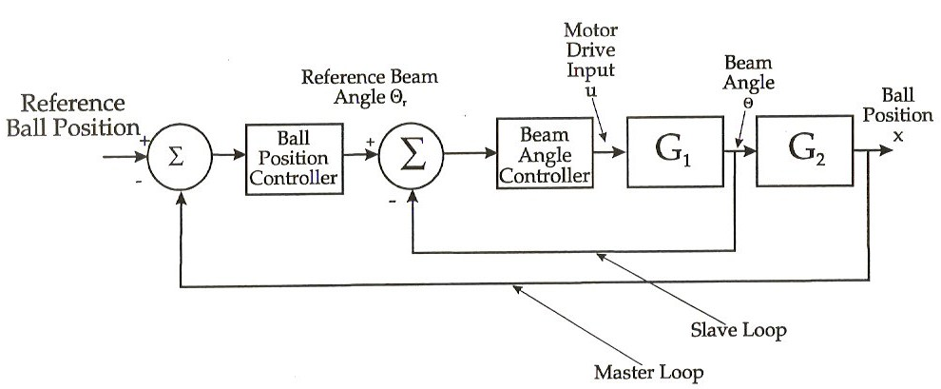

Figure 10

As shown in Figure 10, the inner loop is called the slave loop and the outer loop is called the master loop because the master loop determines the reference input for the slave loop. The overall control strategy is called cascade control, and is commonly used when an inner loop is required to control an actuate (like the beam motor) or a similar sub-system.

The explanation given in the following sections reflects the cascade nature of the ball and beam control problem in that it will first consider the modeling of control of the inner loop elements (the drive motor and beam) and then treat the outer loop elements (the ball position controller).

**2.2.3 Drive Motor and Beam : Modeling**

The drive motor tilts the beam through the action of a profiled cam attached to the motor shafts as shown in Figure 10. A retaining spring is attached to the beam to ensure that the Cam Follower is kept in contact with the cam. This is of particular importance when rapid beam angle changes are present. The cam profile is designed to give a linear relationship between the motor/cam shaft angle and the beam angle over a beam angle range of ±10**°**.

The velocity of the cam (and hence the beam angle)  is proportional to the motor input voltage,. Thus it is possible to write for the motor and beam the following equation:

 (1)

Where  is a constant which depends upon the drive amplifier gain an the geometry of the cam. By taking Laplace transforms of the equation (1), the following transfer function  can be obtained for the motor and beam:

 (2)

or , where .

**2.2.4. Drive Motor and Beam : Control**

The purpose of the inner loop (or slave) controller in Figure 9 is to provide good position control over the beam angle, rather than the open-loop situation in which the velocity of the beam angle is controlled. A further aim of the inner loop is to reduce the effect of non-linearity in the gain  in the transfer function of equation (2). Both of these objectives can be achieved using a high gain proportional beam angle controller as shown in Figure 11.

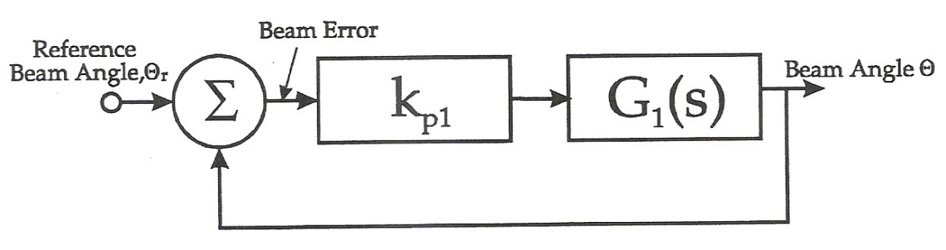

Figure 11

From Figure 11, the closed-loop transfer function is

 (3)

If the proportional gain  is high, then , so that . Also when  is high the dead zone will be ignored as will any other non-linear feature of the motor and drive amplifier.

Thus, with a high gain proportional controller , the motor and drive can be ignored and the control system re-drawn as shown in Figure 12, where the control input is now  the beam angle (or rather the desired beam angle  will be approximately equal to ).

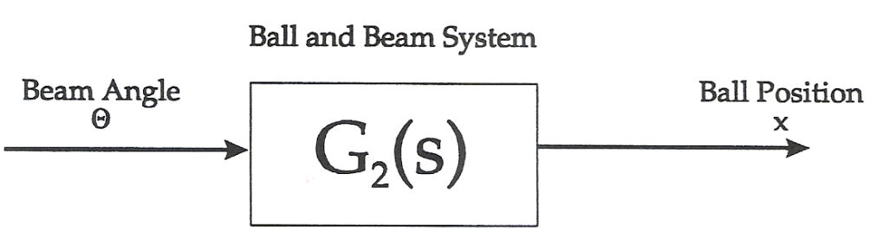

Figure 12

**2.2.5 Ball and Beam: Modeling**

The dynamics of the ball rolling on the beam can be obtained by noting that the force which accelerates the ball as it rolls on the beam is that component of the gravitational force which acts along the beam as shown in Figure 13.



Figure 13

If we simplify the problem by assuming that the ball is sliding without friction along the beam then, form Newton’s Laws:

***Force* = *Mass*  *Acceleration*,**

 (4)

For small angles, , so that we can write from equation (4),

 (5)

Taking Laplace transforms, we obtain the simple transfer function for the ball and beam where  is the beam angle and *x* is the ball position,

 (6)

Thus, the ball and beam transfer function  as illustrated in Figure is

 (7)

This simple model is a good approximation to the true transfer function and will be used throughout the controller design discussions.

**2.2.6. Ball and Beam : Measurement of System Characteristics**

The beam angle sensor characteristic is obtained by first putting the drive motor and beam under closed-loop position control. The reference input to this control loop will be  the desired beam angle.

By applying different voltages,  to the desired beam angle, measuring the corresponding angle  of the beam and plotting the result as shown in Figure 14, the characteristic for the beam angles sensor is obtained.

The ball position sensor characteristic is obtained by measuring the ball position sensor output as the ball is placed at different positions on the beam and plotting the characteristic as shown in Figure 14.



Figure 14

**2.2.7. Ball and Beam : Control**

An open-loop unstable system like the ball and beam needs feedback compensation in order to stabilize the system output. As has been if the system is left with a constant input, the ball will accelerate at a uniform rate towards one end of the beam. Unless prevented from doing so it will fall off. In order to stabilize the ball position on the beam it is necessary to introduce some predictive phase advance mechanism into the controller which will predict the ball movement and make compensating adjustment of the beam angle.

There are two ways of achieving this anticipatory control. The first is by proportional plus derivative control action and the second is by phase advance compensation. Consider first the use of proportional plus derivative action.

**Proportional plus Derivative Control of Ball and Beam.**

Figure shows the ball and beam with proportional plus derivative (PD) controller. From the figure it is possible to see how the derivative action can compensate for the unstable nature of the ball and beam as followings:

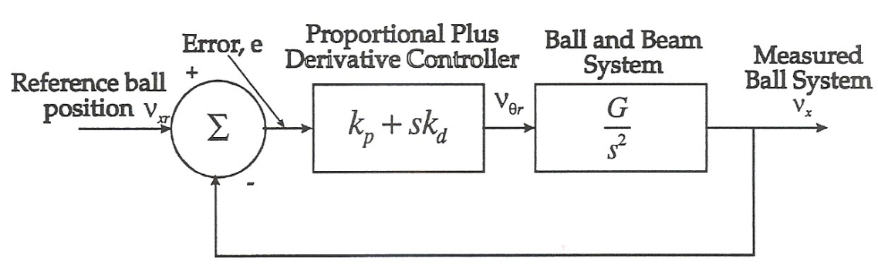

Figure 15

For a constant reference ball position, , as the ball starts to roll the proportional part of the controller produces a proportional controller signal component as shown in Figure 16.

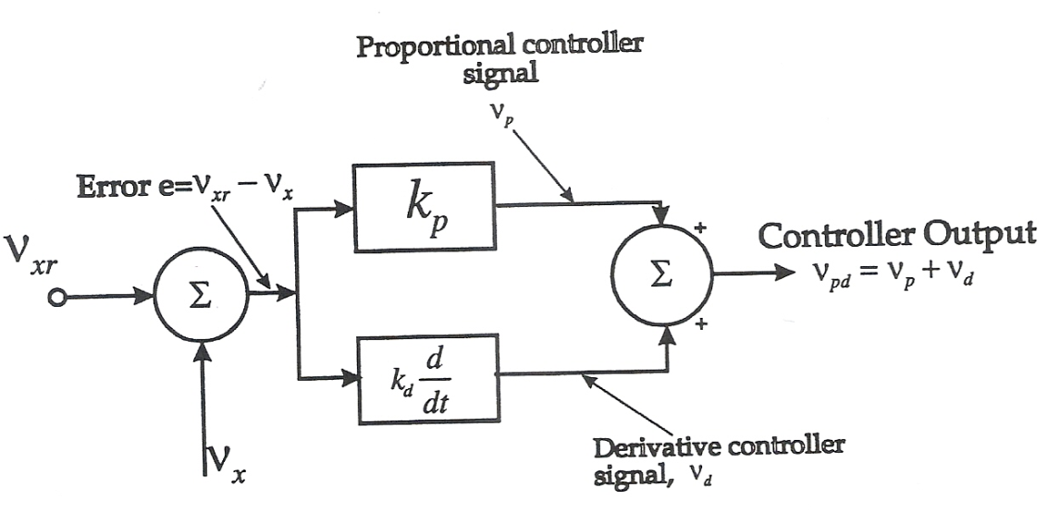

Figure 16

As  exceeds , the proportional controller signal contributed a positive component of the signal to the controller output  which increases the beam angle. The derivative controller signal with a constant reference  given by:

 (8)

Thus if the ball is rolling in a certain direction, the derivative signal  applies a corrective signal which is proportional to the ball velocity as sensed by . In this sense the derivative term is able to predict the balls movements and make compensating adjustments much sooner than the proportional controller signal.

The behavior of PD action control is determined in transfer function from the block diagram of Figure 15, by writing the closed-loop system equation as

 (9)

Thus the transfer function is stable with closed-loop poles given by . Compare this with the standard second order system equation, , where  is the damping factor and  is the natural frequency. It can be seen by comparing coefficients of these equations that

 (10)

Thus form equation (10) it is possible to select  and  for any desired closed-loop damping factor and natural frequency.

**High Frequency Response Filtering**

When derivative or phase advance action is used in a control loop there is an amplification of high frequency or rapidly changing signals in the feedback loop. It is unusual to introduce some extra filtering action in order to prevent such high frequency signals occurring. This can be done either pre-filtering the reference signal or by a low pass filter introduced inside the feedback loop.

1. **Pre-Filtering**

Figure 17 shown a feedback system where the reference signal  is fed through a low pass filter before being applied to the system. This prevents high frequency signal being injected into the system.

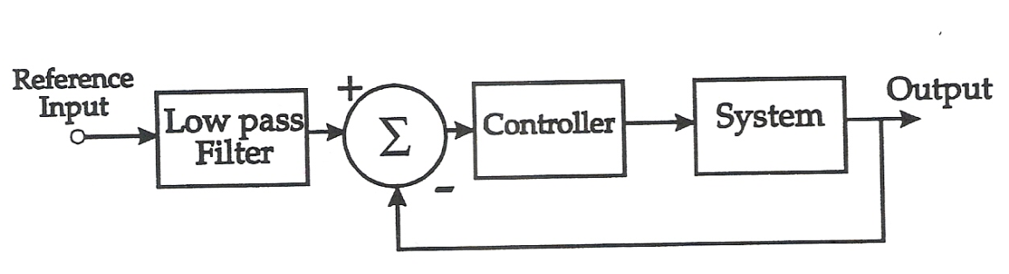

Figure 17

1. **Filtering the loop**

If the high frequency signals occur inside the feedback loop then a low pass filter can be placed after the controller. However, care must be taken not to set the cut off frequency of the low pass filter too low otherwise it will interfere with the reaction of the controller.

1. **Low Pass Filter Implementation**

The low pass filter mentioned above may be easily implemented using an integrator with feedback round it as shown in Figure 18. In this figure, the transfer function is

 (11)

where the low frequency gain is one as required, and the cut off frequency  is .



Figure 18Figure 19 shown the Bode plot for transfer function .

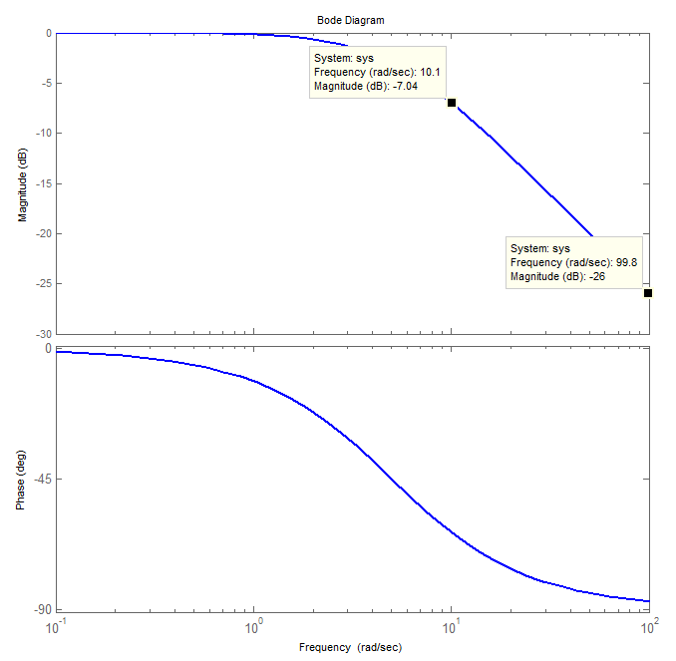

Figure 19

The system with low pass filter can reduce the influence by high frequency noise, and Figure 20 shown the block diagram with filter.



Figure 20

The closed-loop system equation as

 (12)

Thus the transfer function is stable with closed-loop poles given by . Compare this with the third order system equation, , where  is the damping factor and  is the natural frequency. It can be seen by comparing coefficients of these equations that

 (13)

**Section 3 Experimentation**

**3.1 Ball &Beam (MyRIO使用說明書)**

1. 依照以下myRIO接線圖完成接線。



1. 將myRIO裝置接上電源，並利用USB接槽與電腦連接，之後開啟LabVIEW myRIO 2014。

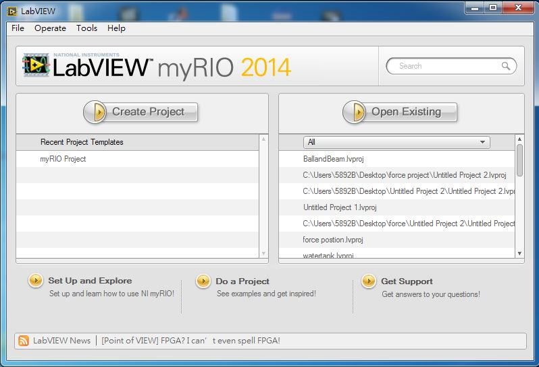

1. 點選File – Open Project – 選擇BallandBeam.lvlps，開啟專案檔如下。

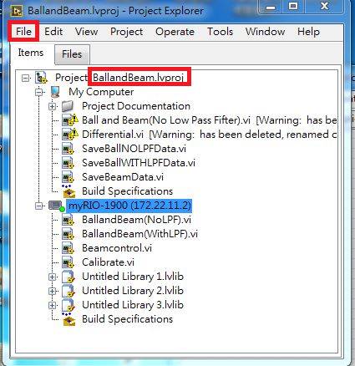

1. 在專案檔中選擇myRIO裝置(myRIO-1900)，按右鍵 – 選擇connect，連線myRIO裝置。

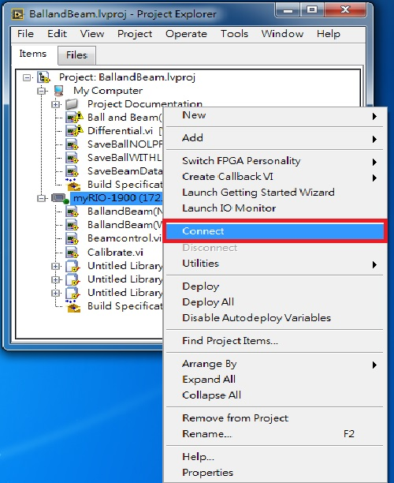

1. 連線之後在專案中的myRIO裝置會亮起綠燈表示連線，完成如下圖。

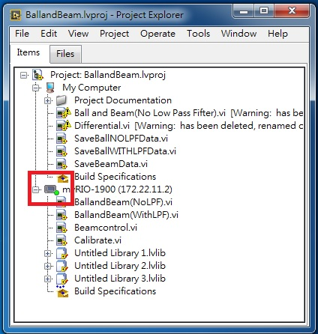

1. 開啟Calibrate.vi。

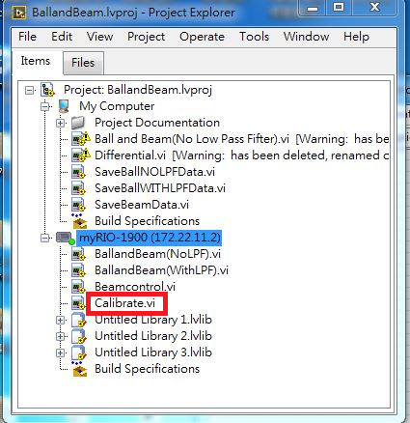

1. 將螺絲起子置於不同位置紀錄X voltage值，並調整不同角度紀錄Theta voltage值。

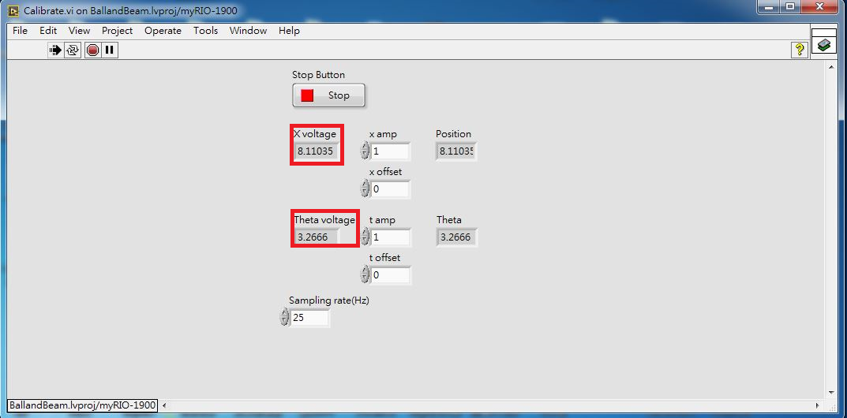

1. 開啟Ball and Beam.xlsx，輸入電壓值，紀錄下線性曲線之兩組a、b值。

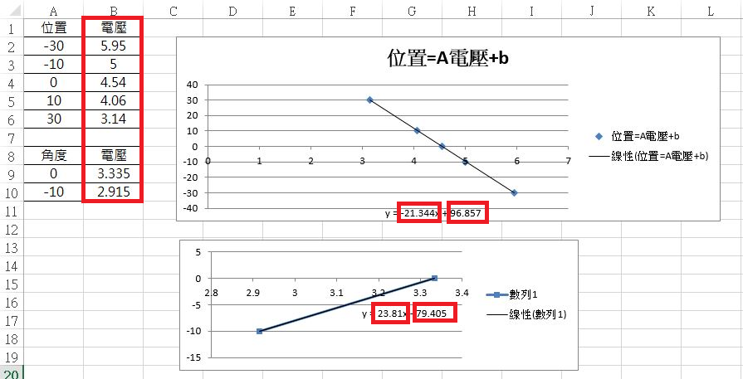

1. 回到Calibrate.vi，輸入兩組a、b值，測試不同位置及角度顯示結果是否正確。

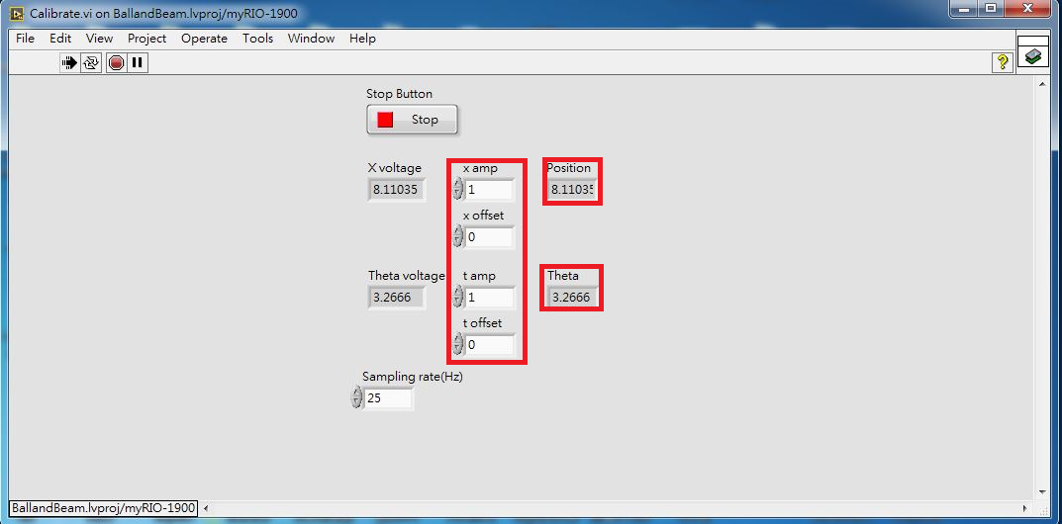

1. 分別開啟RT端(myRIO-1900)的"執行程式"Beamcontrol.vi，與PC端(My Computer)的"存檔程式"SaveBeamData.vi，如下圖示。

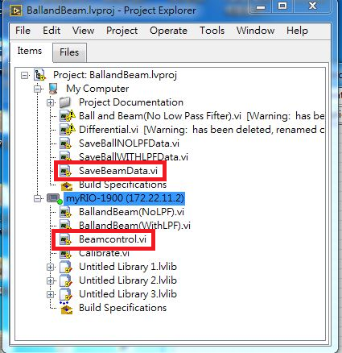

1. 輸入不同參數值→執行”存檔程式”→執行”執行程式”，待機台完成控制目的→關閉”存檔程式”儲存成.txt檔名→關閉”執行程式”，將機台停止作動→利用Matlab將儲存之.txt數據畫出→經由適當的平移將數據對齊。

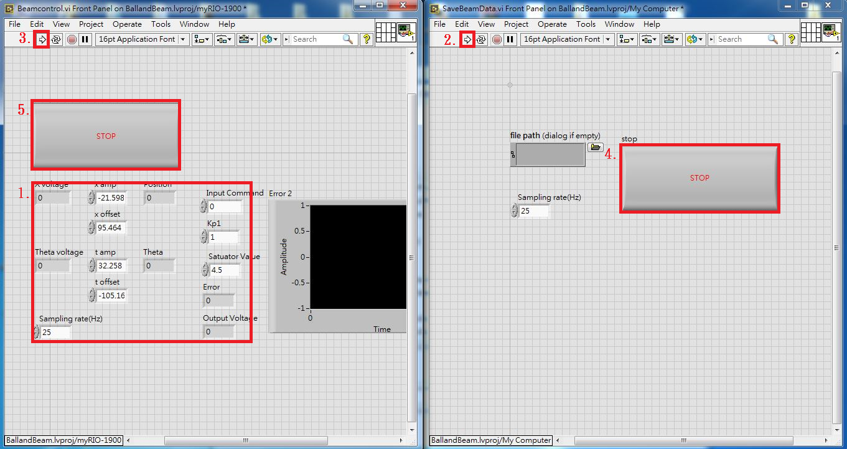

1. 分別開啟RT端(myRIO-1900)的"執行程式"BallandBeam(NoLPF).vi，與PC端(My Computer)的"存檔程式"SaveBallNOLPFDATA.vi，如下圖示。

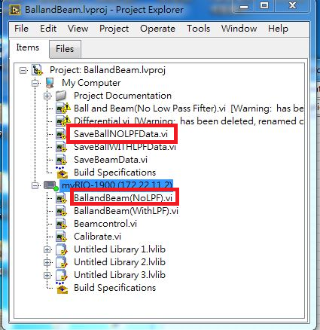

1. 輸入不同參數值→執行”存檔程式”→執行”執行程式”，待機台完成控制目的→關閉”存檔程式”儲存成.txt檔名→關閉”執行程式”，將機台停止作動→利用Matlab將儲存之.txt數據畫出→經由適當的平移將數據對齊。

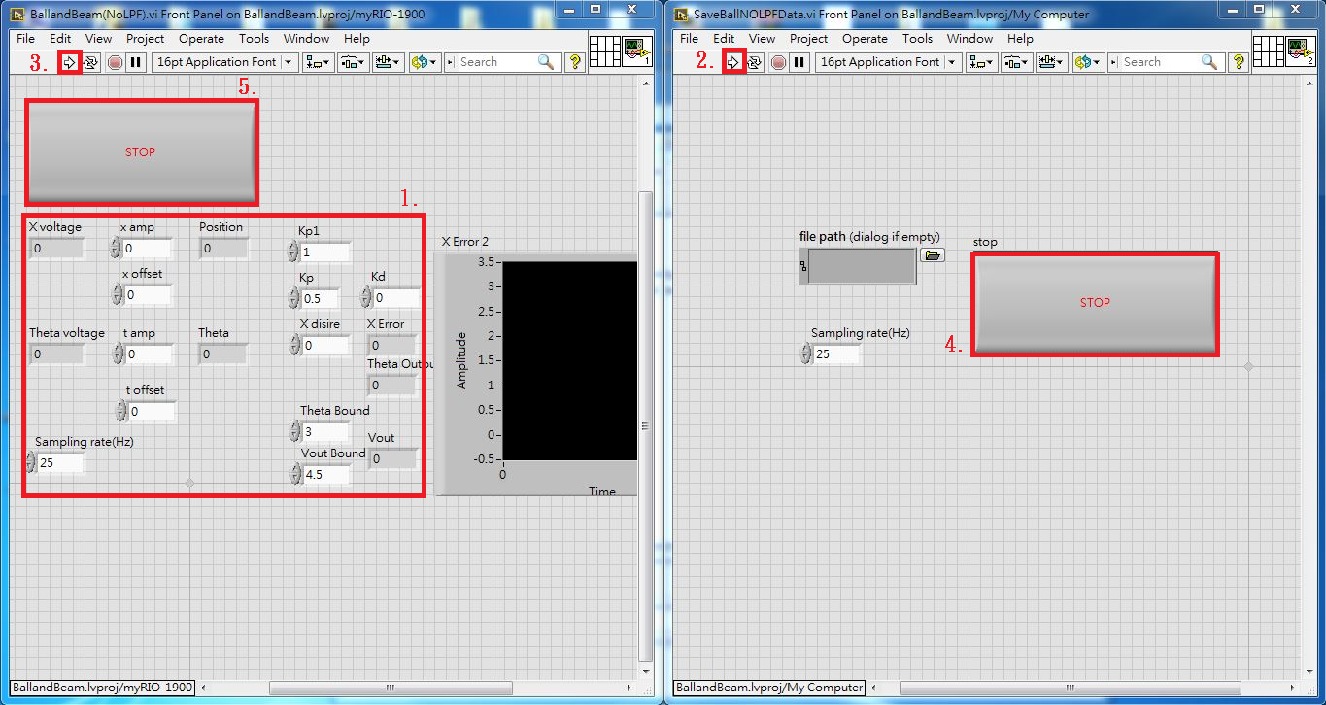

1. 分別開啟RT端(myRIO-1900)的"執行程式"BallandBeam(WithLPF).vi，與PC端(My Computer)的"存檔程式"SaveBallWITHLPFDATA.vi，如下圖示。

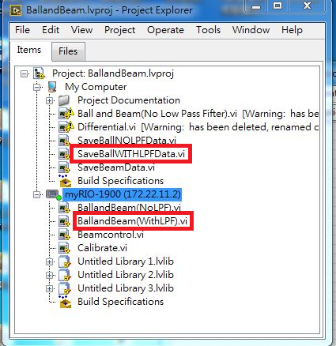

1. 輸入不同參數值→執行”存檔程式”→執行”執行程式”，待機台完成控制目的→關閉”存檔程式”儲存成.txt檔名→關閉”執行程式”，將機台停止作動→利用Matlab將儲存之.txt數據畫出→經由適當的平移將數據對齊。

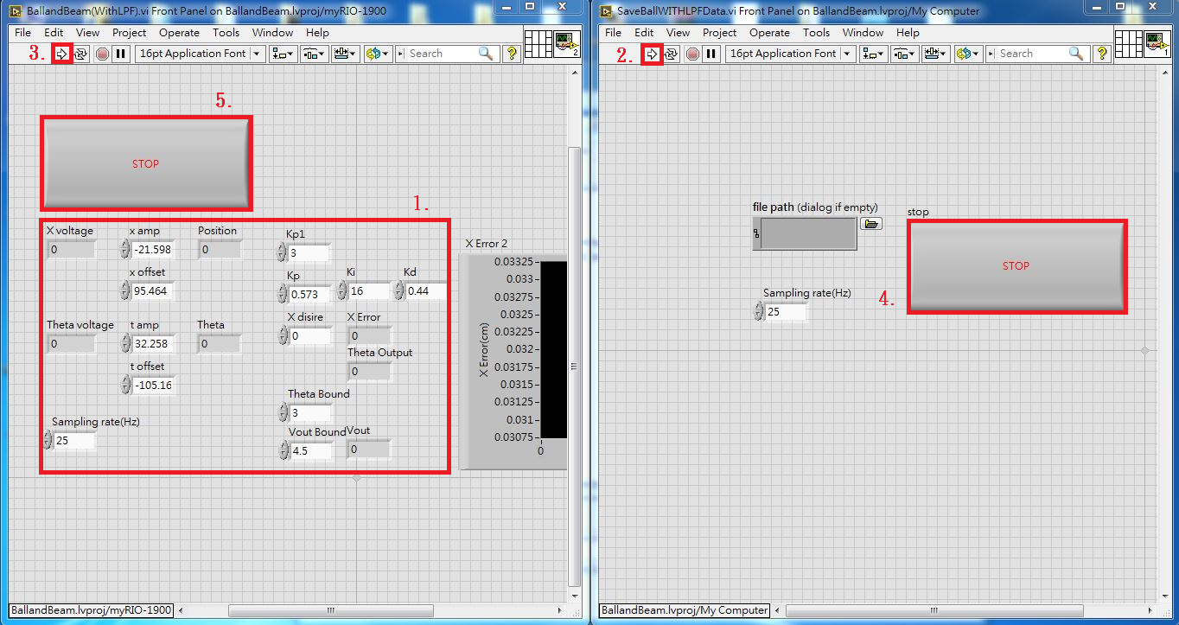

**3.2 Experiment Result**

1. **Calibration**

**(1) Position**

|  |  |  |  |  |  |
| --- | --- | --- | --- | --- | --- |
| Position | -30 | -10 | 0 | 10 | 30 |
| Voltage |  |  |  |  |  |
| $Position=a×Volt+b$ $⟹$ a= b= | | | | | | |

**(2) Angle**

$$V_{0}= { V}_{-10}=$$

$Angle=a×Volt+b$ $⟹$ a= b=

**2. Beam Angle Control**

(1) Desired angle is 0. Please Record the Steady-error and the data in different $K_{p1}$

|  |  |  |  |  |  |  |
| --- | --- | --- | --- | --- | --- | --- |
| $$K_{p1}$$ | 1 | 3 | 5 | 7 | 15 | 20 |
| Steady-error |  |  |  |  |  |  |

(2)Data Plot

**3. BALL AND BEAM EXPERIMENT**

(1) Find the parameter $K_{p},K_{d}$ of the control ,with different damping ratio  and natural frequency $ω_{n}$

|  |  |  |
| --- | --- | --- |
|  | $$K_{p}$$ | $$K_{d}$$ |
| $$ξ=1,ω_{n}=3$$ |  |  |
| $$ξ=0.707,ω_{n}=1$$ |  |  |
| $$ξ=0.707,ω_{n}=3$$ |  |  |
| $$ξ=0.5,ω_{n}=1$$ |  |  |
| $$ξ=0.5,ω_{n}=3$$ |  |  |
|  |  |  |
|  |  |  |



(2) Desired position is 0 cm. Set up all the parameter and plot the performance data.

**Discussion**

* 1. Why we use a Cam to drive the beam to change angle but not use motor to drive the beam to change the angle ?
  2. Explain when we were at beam angle experiment, why not we can make  only with ?
  3. Explain when we were at beam angle experiment, what reason cause the different phenomena with different ?
  4. Do you think this system is a stable system? What is your reason?